\*\*\*\*\*\*\*\*\*\*\*\*\*\*\*\*\*\*\*\*\*\*\*\*\*\*\*\*\*\*\*\*\*\*\*\*\*\*\*\*\*\*\*\*\*\*\*\*\*\*\*\*

Name: DONG CHAN OH

Student ID: 128975190

Purpose: Assignment 01 DCF255

\*\*\*\*\*\*\*\*\*\*\*\*\*\*\*\*\*\*\*\*\*\*\*\*\*\*\*\*\*\*\*\*\*\*\*\*\*\*\*\*\*\*\*\*\*\*\*\*\*\*\*\*

1. Structure the airline travel system by supposing that you travel from Toronto to London by air.

a. Identify and discuss the series of actions you take in a five layered architecture from the start of your journey at Toronto and then five layered actions at the arrival on destination London. [4 Marks]

We suppose to describe the airline travel system from Toronto to London. This system has stages that are (1)ticketing(purchase), (2)baggage(check), (3)gating(load people, bags), (4)Taking off, and (5)routing airplanes(to its destination). After our plane lands, we de-plane at the gate and claim our bags. We can see this scenario is similar to computer networking. We are shipped from source(Toronto) to destination(London) by the airline like a packet in the Internet.

b. Support your answer by drawing a layered architecture at the starting point of the journey and the destination. Your answer must identify and discuss the action identified both at Toronto and London. [4 Marks]

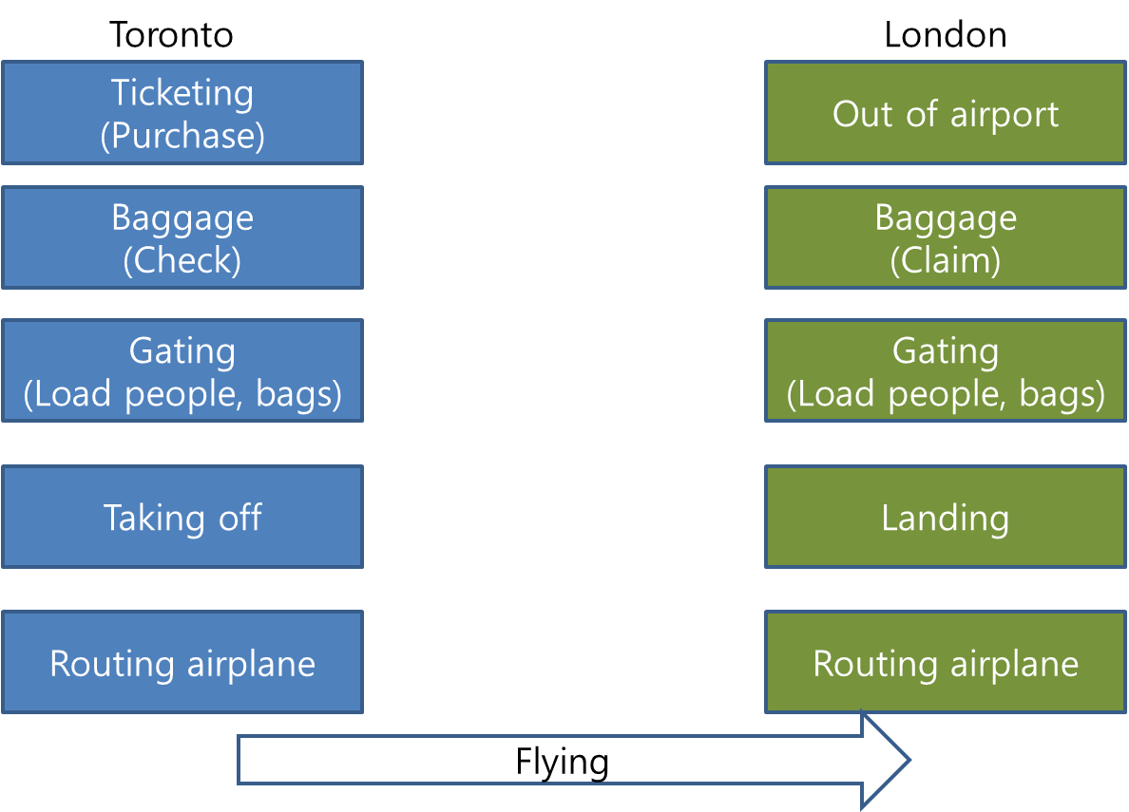

2. Assume that you are accessing a Seneca website from your home computer (desktop/laptop/tablet).

a. Identify and discuss the method used at your home to access the Internet and then connection with the Seneca web server. [4 Marks]

Using the Internet, computers connect and communicate with one another, primarily using the TCP/IP (Transmission Control Protocol / Internet Protocol). My home has a network router that connects to my ISP(Internet service providers) which uses the TCP/IP protocols to make connections.

The router is given the IP address for my connection to the Internet and then assigns local IP addresses to my device. When accessing a local computer in my home network, my router sends my TCP/IP packets. However, when I want to connect to the Internet, the router uses the IP address assigned by the ISP. That is, when connected to an ISP, I am assigned an IP address, which is a unique address given to my computer or network to communicate on the Internet.

When requesting information from a web page such as Seneca website, I enter a URL that is easy to understand. For my computer to access the Seneca web pages, that URL must be converted into an IP address, which is done with DNS. Once DNS has converted the URL into an IP address, the routers on the Internet will know how to route my TCP/IP packet.

b. Sketch/draw a network connection from your device to the Seneca web server. [4 Marks]

